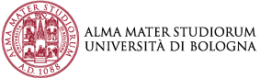
WATER AND AGRICULTURE

The research activities address a variety of hydraulic-technological, economic, agronomic, genomic and environmental aspects to make agricultural water (re)use more sustainable and efficient

Our research objectives
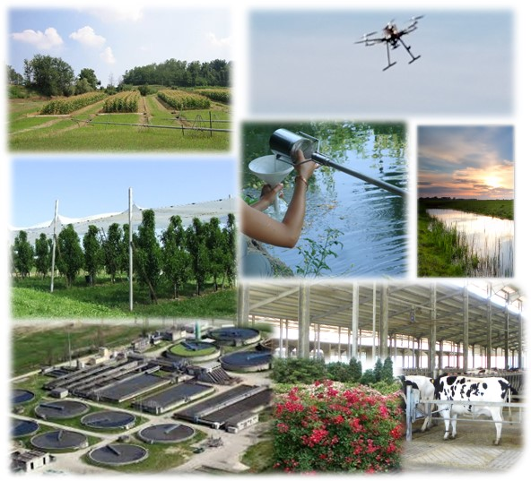
- Promoting sustainable water use in agriculture
- Increasing knowledge on the impact of climate change on agricultural and natural ecosystems
- Developing drought adaptation and mitigation strategies for the resilience of the agricultural sector
- Facilitating technological transfer and innovation adoption to maximize water use efficiency
- Safeguarding the safety and sustainability of the water resource in different agricultural, natural and social environments

Our expertise
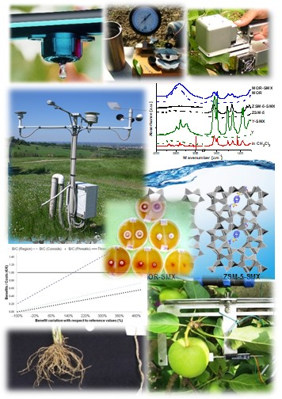
- Economics and policy in water management and innovation uptake
- Agroclimatology and agrometereology
- Crop physiological and productive responses to drought stress
- Genomic research and breeding for new drought tolerant genotypes
- Technical solutions for agroindustrial buildings and husbandry
- Remote sensing, georeferenced maps and variable rate irrigation
- Digital solutions, plant based sensors and decision support systems for precise irrigation
- Chemical, physical and microbiological quality of water
- Phytodepuration and bioremediation strategies
- Benefits/risks derived from the use of wastewater
- Hydraulic-environmental water management

Our main projects
INTERNATIONAL
- Rooty: A Root Ideotype Toolbox to Support Improved Wheat Yields H2020 (2018 – 2022).
- CONSOLE - CONtract SOLutions for Effective and lasting delivery of agri-environmental-climate public goods by EU agriculture and forestry H2020 (2019-2022)
- FIT4REUSE - Safe and sustainable solutions for the integrated use of non-conventional water resources in the Mediterranean agricultural sector PRIMA (2019-2022)
- DROMAMED - Capitalization of Mediterranean maize germplasm for improving stress tolerance –PRIMA (2020-2023)
- SOMMET - EURAMET Metrology for soil moisture H2020 (2022 – 2025)
- BONEX - Boosting Nexus Framework Implementation in the Mediterranean PRIMA (2022 - 2025)
- GREENing the BLUE canals infrastructure of Reno basin to enhance ecosystem connectivity and services LIFE (2019-2026)
- CEREALMED: Enhancing diversity in Mediterranean cereal farming systems PRIMA (2020-2023)
- FruitCREWS - Fruit tree Crop REsponses to Water deficit and decision support Systems applications for precise irrigation - COST ACTION (2022-2026)
- CLEANFOREST - Joint effects of Climate Extremes and Atmospheric deposition on European forests - COST ACTION (2022-2026)
NATIONAL
- TARANTO Tecnologie e processi per l’abbattimento di inquinanti e la bonifica di siti contaminati con recupero di materie prime e produzione di energia totally green (PON R&I) (2019-2022)
- INCIPIT Integrated computer modeling and monitoring for irrigation planning in Italy (PRIN 2017) (2019-2022)
- 2D-Nano-Mad-Plants: Effects of 2D-nanomaterials on seed plants reproduction PRIN (2021-2024)
- Implementazione dell’Analisi Economica ex DQA a supporto della pianificazione per il
distretto idrografico del fiume Po (progetto finanziato da AdbPo) (2021-2024)

REGIONAL
- S3O - Smart Specialized Sustainable Orchard (2020-2021) (POR-FESR)
- REpHYT Fitodepurazione e riuso per la riduzione dei nutrienti e fitofarmaci nelle acque di superficie del reticolo di bonificaPSR Emilia Romagna (2020 - 2022)
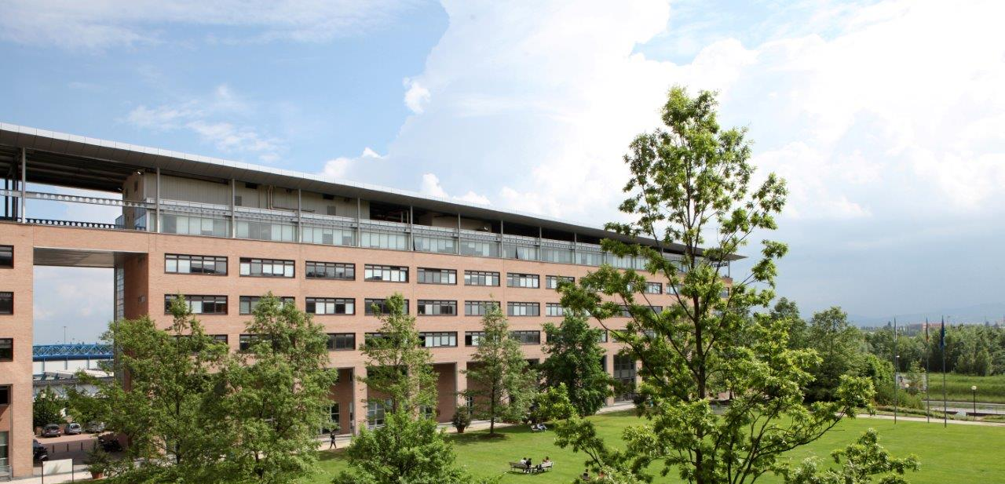
- MIRALO - Analisi genotipica e fenotipica per caratteri radicali di una collezione di germoplasma italiano di mais. PSR Lombardia (2021-2024)
Contact us
Department of Agricultural and Food Sciences, DISTAL
Viale G. Fanin, 40-50
40127, Bologna (Italy)

distal.ricerca@unibo.it
www.distal.unibo.it

